PEST MANAGEMENT OPERATORS TRAINING MANUAL

MoDuLE 2 MAnAgEMEnt oF uRbAn PEstS

Pest Management and Pest Control

Pest Diagnosis

Assessing Pest Activity and infestation Levels

The Control Options

Pesticides

Formulations and Adjuvants

**Objectives of this Module:**

1. To define the terms Pest Management and Pest Control
2. To outline the steps involved in developing a pest management programme
3. To review the different types of pest management strategies
4. To discuss why these pests are of economic importance

**Pest Management and Pest Control**

Over the last 50 years, there has been a gradual shift from pest control to pest management. **Pest control** implies a two-strand approach, which combines the use of technology (such as use of pesticides, and pesticide application equipment) with biological knowledge (informing where, when and how to apply the technology) to reduce pest impact (by killing the pest). **Pest management**, on the other hand, aims to reduce pest impact and injury levels to a tolerable level through multiple tactics, which are not solely dependent on killing the pest. Hence, while pest control seeks to eliminate a pest organism from an area by a single—often chemical control— strategy, pest management seeks to utilise various strategies in a sustainable manner to suppress the population of the pest below the impact level.

**The principles of pest management are to:**

* Correctly identify the pest organism and to assess and monitor the pest population to determine when the pest has reached the economic impact level and the need for action.
* Select and integrate a variety of control strategies in a manner that is complementary in order to suppress the pest population.
* Maintain the pest population at, or below, levels that cause economic damage, rather than trying to eradicate the pest.
* Place emphasis on ecological management strategies and use chemical control as a last resort.
* Treat the entire ecosystem as the management unit.

When developing a pest management programme, you should include all of the following elements:



**Pest Diagnosis**

In order to protect the health of human beings and the environment, while effectively suppressing pest populations, pest control options that form part of a pest management programme are usually target-specific. As a result, the pest being targeted should be correctly identified. it is, therefore, necessary to visit the affected site, inspect the damage and collect specimens for identification. Where specimens of the pest organism are not available, fecal pellets, pelt/shed casts records and other pest remnants may be used. The damage caused by the pest, or evidence of pest activity, may also be used to assist in identification. When in doubt, seek assistance from relevant professionals or institutions.

**Assessing Pest Activity and Infestation Levels**

Understanding the activity of pests is a very important aspect of pest management. It is the basis for deciding if and when action is to be taken against a pest. Constant monitoring and survey of pest populations is a basic tenet of any pest management programme and provides useful information on the presence or absence of the pest, the population density and distribution of the pest, and the feeding and reproductive activity of the pest.

A pest assessment involves the collection of information on pest numbers, pest activities and economic impact. these surveys can be qualitative or quantitative. Qualitative assessments usually detect the presence or absence of a pest, while quantitative assessments determine the abundance and distribution of the pest in time and space.

When doing an assessment, it is often impossible to count every individual in a pest population and hence, you will have to sample/take samples of the pest population. this usually requires:

1. A sampling technique, which is the method used to collect information on the pest.
2. A sampling programme, which indicates when and where samples should be taken.

Sampling techniques may be direct or indirect. Direct samples (direct counts, netting and traps) involve an assessment of the actual pest population, while indirect samples assess damage and other things (nests, pelts and excreta) associated with the pest.

**The Control Options**

There are four major types of control strategies that are available for use in a pest management programme:

1. ecological management (cultural control),
2. physical control,
3. biological control, and
4. chemical control.

***Ecological Management***

Ecological management involves the manipulation of the food source or the physical environment to make it less favourable for the pest organism. To successfully implement an ecological management programme, one needs to understand the ecology of the pest. it is important to determine the ecological requisites of the pest, the availability of the requisites in the environment and the behaviour of the pest in attaining those requisites.

The major pest requirements include food, water, appropriate space for feeding and reproduction, and shelter from weather extremes and natural enemies. Ecological management links to the life cycle of the insect pest.

**Ecological management procedures are grouped into four major categories:**

1. ***Reduction of the average favourability of the ecosystem.*** This involves lowering the pest density by reducing the availability of food, shelter and habitable space. Proper sanitation is a major component of this strategy.
2. ***Disruption of the continuity of requisite food sources.***

This involves manipulation of the presence of the host material in time and space to eliminate the requisites of the pest.

1. ***Diversion of pest populations from the host involves diversion of the pests away from the material of economic importance.***

This is achieved by using a repellent substance and presenting the pest with a more favourable alternative.

1. ***Reduction of the impact of pest injury.***

This involves modification of the host material to minimise losses from injury.

***Physical Controls***

Physical control involves activities that physically separate the pest from its host or management area, which includes the area in which the pest lives, feeds, mates and roams/forages for food. This may involve the *driving out* of the organism *chemical or audio repellents* or the establishment of physical barriers that prevent the pest organism from gaining access to the host or the managed environment.

Strategies employed as physical control include the erection of barriers such as screens and nets; *plugging/caulking of holes and cracks/crevices, coving at the base of walls, management of ambient conditions (e.g. temperature, humidity, airflow, lighting), installing sealed garbage bins, etc.*

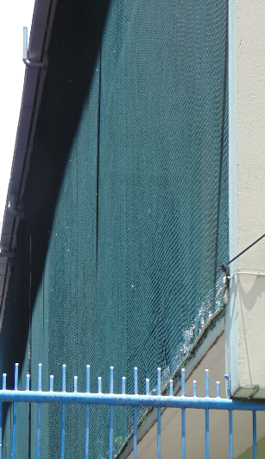

Screen Door Bird Netting

***Mechanical Controls***

Mechanical control devices include all types of traps (e.g. snap, glue, UV, high voltage, cage, mist nets) and can involve the removal of both live and dead catch.

 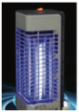 **Figure 13.** Forms of mechanical control e.g. sticky fly paper (left) and UV light trap (right).

***Biological Control***

Biological control is the use of natural enemies (organisms that prey on other organisms) to suppress the population of a pest species. There are three major biological control strategies; introduction (Classical), augmentation and conservation. Classical biological control (which involves introduction of natural enemies from the place of origin of the pest) and augmentation (releasing natural enemies in an area where the natural enemy population is low and not effective in reducing pest numbers) are forms of biological control that may not be appropriate or feasible for implementation by pest management operators. However, most operators should be able to implement conservation biological control strategies as part of a pest management programme if deemed necessary.

Conservation is a form of biological control that involves the conservation and protection of natural enemies existing in an ecosystem. *Conservation measures not traditionally a component of pest control strategies but pest management operators understand the importance of the protection of natural enemies*. This involves maintaining their habitat and reducing the use of substances that are toxic to the natural enemies.

***Chemical Control***

Chemical control is the use of a chemical substance to suppress a pest population. It is a quick and effective ways to reduce a pest population and is therefore an important curative method. Chemical control is, however, the most detrimental control method to human beings and the environment and should be used as a last resort. *A much safer alternative to commercial pesticides are a variety of botanical oils and plants that make effective repellents against many insects and vertebrates.*

**Pesticides**

Pesticides are chemical or biochemical compounds used to kill or suppress the population of organisms deemed to be pests.

*Pesticides may be categorised according to:*

* the target pest
* how dangerous they are to humans and the environment/ level of toxicity
* their mode of action
* their chemistry

The classification of pesticides according to these categories is illustrated in the following sections.

***Target Pest Classification***

This grouping is defined by the pest that the pesticide was developed to kill.

***Hazard Classification***

Pesticides are categorised according to the World Health Organization (WHO) classification system, which was developed over time in consultation with countries, international agencies, and regional bodies. The WHO classification is based primarily on the acute oral and dermal toxicity to the rat (since these determinations are standard procedures in toxicology) and distinguishes between the more and the less hazardous forms of each pesticide, based on the toxicity of the technical compound and on its formulation. The classification of pesticides, according to WHO, is given in **Table 1**.

**Table 1.** The determination of WHO hazard classification based on acute LD50 (rat) of formulated products (mg/kg)

The **Globally Harmonized System (GHS) of Classification and Labelling of Chemicals** is now widely used for the classification and labelling of chemicals worldwide. The GHS establishes classification criteria for physical, health and Environmental hazards, along with associated hazard communication elements, notably pictograms, signal words, and hazard statements for use on labels.

The GHS is based on harmonising major existing systems for classifying and labelling of chemicals in transport and in the workplace, in pesticides, and in consumer products. Hence, the GHS harmonisation effort should be accomplished without lowering the level of protection afforded by existing systems. It should be noted that changes in all systems would be required to achieve a single, globally harmonised system. The WHO classification is now aligned in an appropriate way in different categories with the GHS as shown in **Table 2**.

**Table 2.** Comparison of WHO (World Health Organisation) and GHS (Globally Harmonized System) pictograms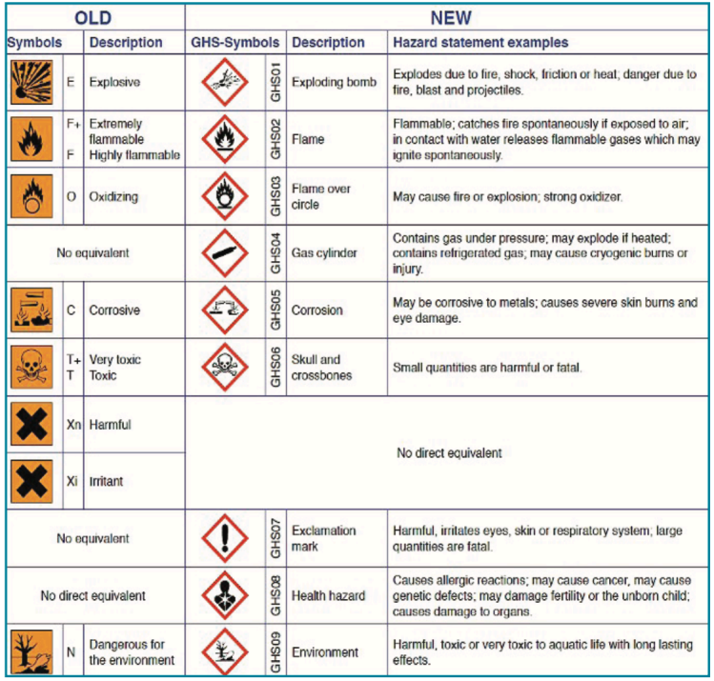



***Mode of Action Classification***

Pesticides may act by coming into contact with, or being ingested or absorbed by the target organism. The route taken by a pesticide and how it then acts on the pest can also be used to group pesticides.

* Contact—kills after direct contact with pest.
* Stomach—kills after pest feeds on treated material.
* Systemic—substance is absorbed by leaves and roots of the plant and is transported within the plant, killing plant (herbicide) or pests which feed on the plant some distance from the point of application.

Once absorbed into the organism, they may exert their effect by different modes of action, which can affect, for example, the nervous system, the endocrine system, as well as voluntary and involuntary muscles.

***Formulations and Adjuvants***

Pesticides are highly toxic chemicals that must be diluted for the safety of the people who handle it during transportation and application. In addition to improving safety, pesticides are formulated to also enhance their effectiveness, ease of application, handling and shelf life. A pesticide formulation consists of the active ingredients (a.i.) and other inert ingredients (adjuvants). some of the ingredients that may be used in the formulation of a pesticide are given in table 3 below.

***Table 3:*** *ingredients used in the Formulation of Pesticides*

***Types of Formulations***

When a pesticidal compound is manufactured, the active ingredient (a.i.) is in a fairly pure form or **technical grade material**. After formulation, the final pesticide product, which is ready for sale, is available in a wide range of forms, some of which are ready to use as they are, while others have to be diluted. Some common formulations are given in the table 4.

***Concentrations of Formulations***

Formulations usually indicate the amount of active ingredient present e.g. 50EC, 10g and 75WP contain 50, 10 and 75% a.i., respectively and 50, 90 and 25% additives, respectively.

***Table 4:*** *Common Pesticide Formulations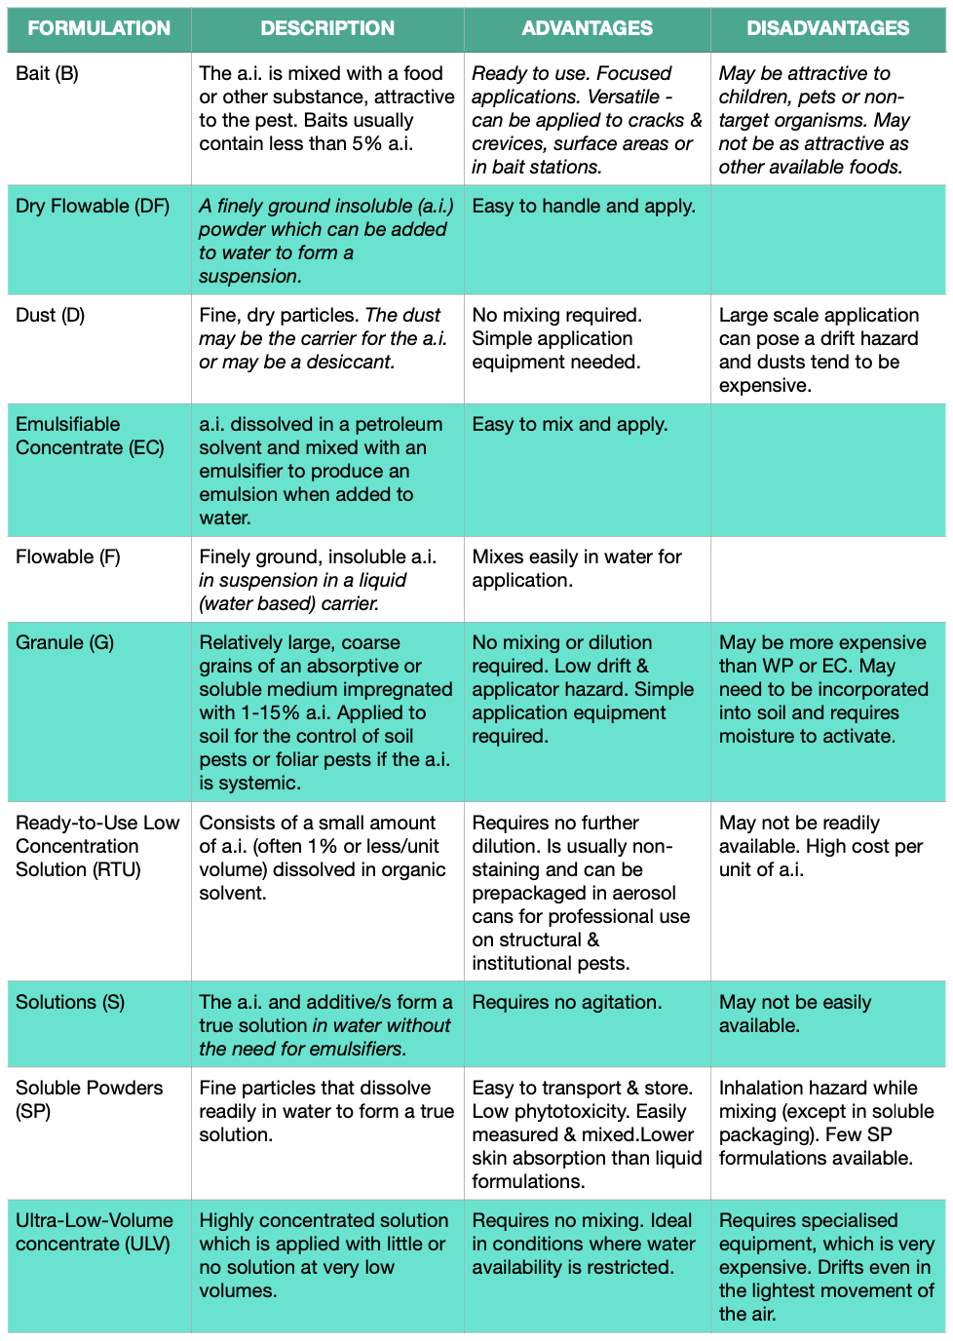*

*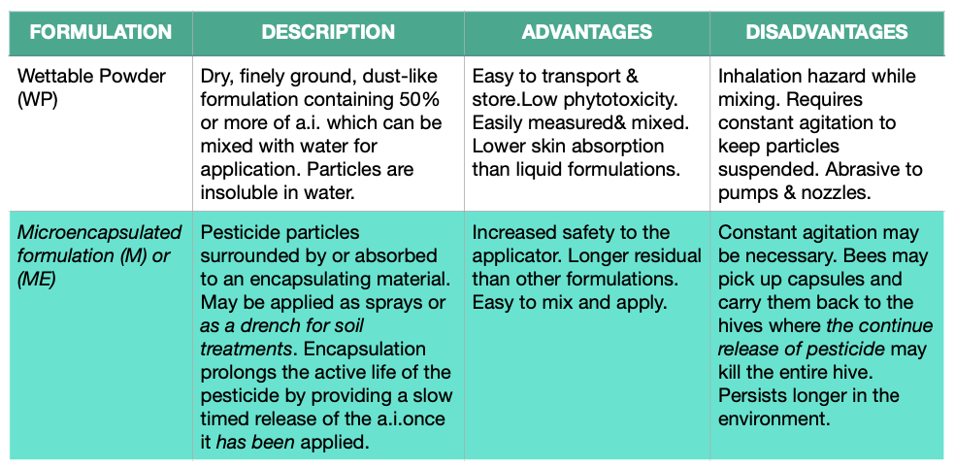****Table 5:*** *A Comprehensive List of Pesticide Formulations & Abbreviations*

